**“WORLD’S DUMBEST HEADLINES GENERATOR: WHERE NONSENSE BECOMES BREAKING NEWS DAILY”**

**Overview**

This Python project is designed to generate **random, humorous, and absurd news headlines** using predefined word lists. The headlines are constructed by randomly selecting words from several creative categories like **Subjects**, **Objects**, **Actions**, **Places**, **Sports**, and **Politics**. It's interactive, engaging, and showcases how simple logic can lead to entertaining results.

## ****Introduction****

In today's world of fast-paced digital content, news spreads quickly—and so does misinformation. This project is a humorous take on that reality. It involves building a **Fake News Headline Generator** using basic Python programming. The aim is not to misinform, but to **entertain and demonstrate how simple code logic can create amusing, absurd, and fake news headlines** based on random word combinations.

## ****Objective****

## To build an interactive Python program that generates funny, random news headlines.

## To explore how randomness, logic, and creativity can be combined in programming.

## To understand and apply basic Python concepts like lists, loops, user input, and string formatting.

## ****Tools & Technologies Used****

* **Programming Language**: Python 3
* **Core Libraries**: random, built-in input/output functions
* **Platform**: Any Python IDE or terminal

## ****Methodology****

### a) **Word Categories Used:**

### To create diverse and hilarious headlines, we structured our words into the following categories:

### **Subject**: The person or entity (e.g., Alien, Cricketer, Minister)

### **Action**: What they’re doing (e.g., eats, dances with, signs)

### **Object**: What’s involved (e.g., pizza, policy paper, football)

### **Place/Location**: Where it’s happening (e.g., in Parliament, on Mars)

### **Sports**: Sport-related roles and events (e.g., umpire, World Cup, red card)

* **Politics**: Political roles and scenarios (e.g., Prime Minister, campaign trail, Parliament)

### b) **Headline Generation Process:**

1. **User selects a theme** – funny, sports, or politics.
2. The program **randomly picks** a subject, action, object, and place from the selected category.
3. A **template** is filled with the selected words using **string concatenation** or **f-strings**.
4. The final headline is **displayed**.
5. The user is asked if they want another one; the process continues until they say “no”.

**Categories Used in the Headline Generator:**

1. **Subject** – Who is in the headline?  
   Examples: Alien, Cricketer, Prime Minister, Banana, Robot
2. **Action** – What are they doing?  
   Examples: dances with, eats, tackles, signs, paints
3. **Object** – What is being interacted with?  
   Examples: pizza, football, selfie stick, campaign hat
4. **Place/Location** – Where is it happening?  
   Examples: on the moon, in Parliament, at World Cup, on Instagram
5. **Sports Theme** – Sports-specific words for subject, action, object, place  
   Examples: Goalkeeper kicks, wrestler punches, in locker room
6. **Politics Theme** – Political roles, items, and settings  
   Examples: MLA resigns, Minister throws flag, at protest rally

**How It Works:**

* User selects a category: funny, sports, or politics
* Program picks a **random subject, action, object**, and **location** from the selected category's word bank
* Fills those words into a **random template** (headline structure)
* Displays the fake headline
* Asks the user if they want to generate another

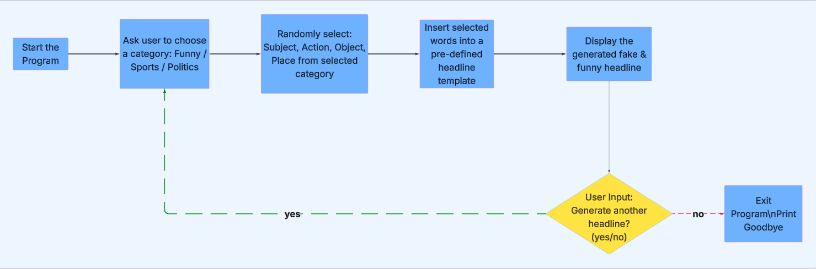

**Concepts Used:**

| **Component** | **Purpose** |
| --- | --- |
| random.choice() | Randomizes the content |
| Templates | Give variety to headline structure |
| Word Lists | Add creativity per category |
| Loop | Allows multiple headlines to be generated |
| Input/Output | Engages user for interaction |

**Code:**

| **Step** | **What It Does** |
| --- | --- |
| **Step 1** | Defines **templates** for how the headline will look. Each template has placeholders for subject, action, object, and location. |
| **Step 2** | Creates **separate lists** of subjects, actions, objects, and locations under each category: Funny, Sports, and Politics. |
| **Step 3** | Welcomes the user to the headline generator. |
| **Step 4** | Asks the user to select one of the three categories. |
| **Step 5** | Based on the user's choice, it **randomly selects** one word from each list using random.choice() to fill the placeholders. |
| **Step 6** | Chooses a random headline **template** and replaces the placeholders with the selected words. |
| **Step 7** | Displays the final, funny/fake headline on screen. |
| **Step 8** | Asks the user if they want to create another headline. If not, the program ends with a thank-you message. |

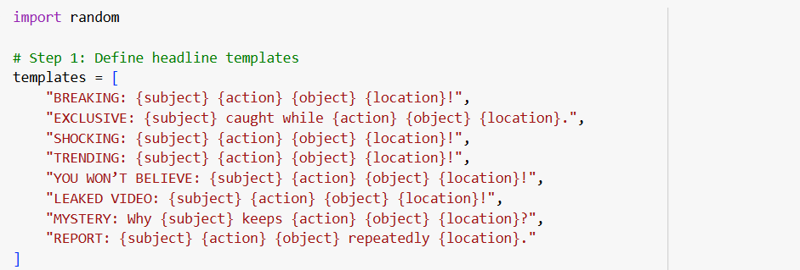

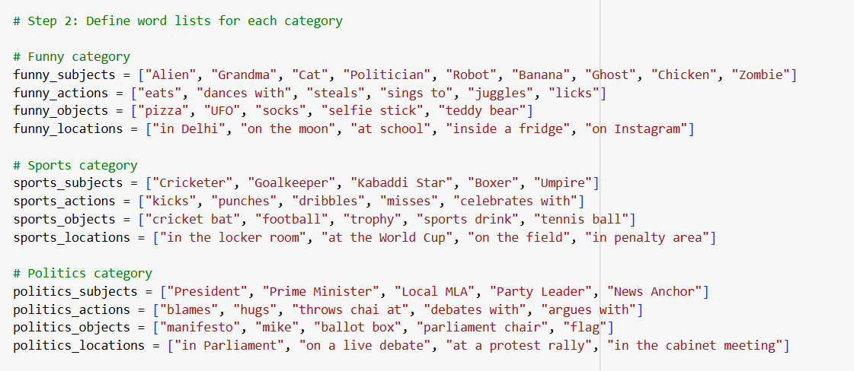





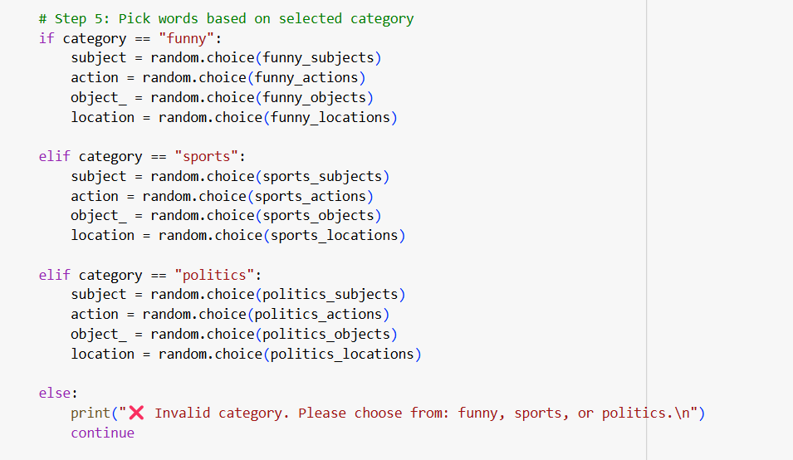

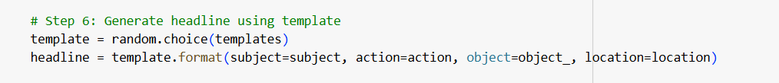

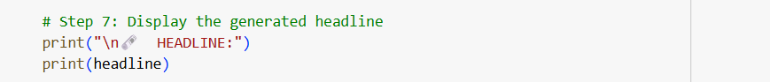

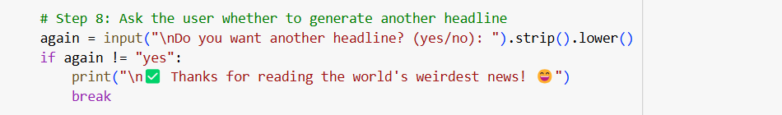

Output

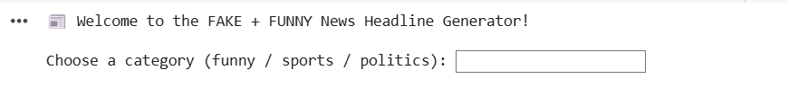

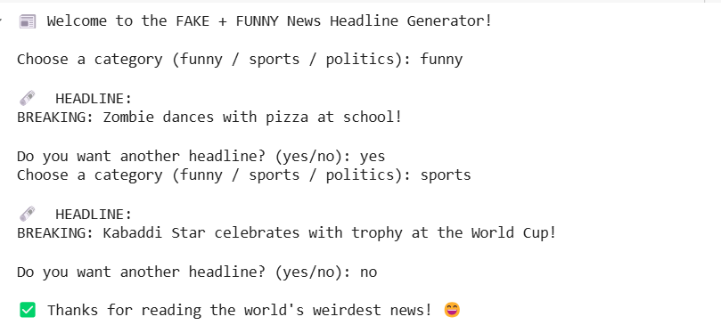

## ****Conclusion:****

This Fake News Headline Generator is a fun yet educational project that bridges **entertainment with core programming concepts**. It showcases how even basic Python tools can create engaging outputs, and opens the door for extending the idea with NLP, GUI, or even AI-based humor detection in the future.